Water Me

Use-Case Specification: Manage plants

Version <1.0>

Revision History

|  |  |  |  |
| --- | --- | --- | --- |
| **Date** | **Version** | **Description** | **Author** |
| <04/12/2016> | <1.0> |  | Olga Akymenko |
|  |  |  |  |
|  |  |  |  |
|  |  |  |  |

Table of Contents

1. Use-Case Name 4

1.1 Brief Description 4

2. Flow of Events 4

2.1 Basic Flow 4

2.2 Alternative Flows 5

3. Feature File 5

4. Preconditions 5

4.1 Camera/Foto 5

5. Postconditions 5

5.1 Avatar/Information 5

5.2 Humidity data 5

6. Extension Points 5

Use-Case Specification: Manage plants

# Use-Case Name

## Brief Description

User has the ability to add a new plant in the list. Also, change the image and add information about the plant (the optimum humidity level).

# Flow of Events

## Basic Flow

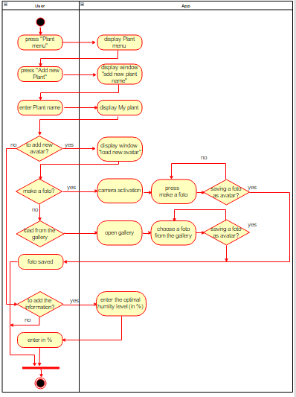

## Alternative Flows

(n/a)

# Feature File

# Preconditions

## Camera/Foto

User has installed the application and is in the "Plant menu". The phone has a camera or at least one photo in the gallery.

# Postconditions

## Avatar/Information

The plant will be a avatar.

## Humidity data

The information about the level of humidity data will help to ensure that the user would received a message about the need for watering in time.

# Extension Points

(n/a)